Documentation: GCP Vision API

1. To analyze the different features present in an image I have looked at GCP’s Vision API as an option in this document.
2. GCP offers 300$ free credits on signup which makes it affordable for using the API for at least testing purposes.
3. It provides the following features which can be used as per requirements.

| CROP HINTS | Determine suggested vertices for a crop region on an image. |
| --- | --- |
| DOCUMENT_TEXT_DETECTION | Perform OCR on dense text images, such as documents (PDF/TIFF), and images with handwriting. TEXT_DETECTION can be used for sparse text images. Takes precedence when both DOCUMENT_TEXT_DETECTION and TEXT_DETECTION are present. |
| FACE_DETECTION | Detect faces within the image. |
| IMAGE_PROPERTIES | Compute a set of image properties, such as the image's dominant colors. |
| LABEL_DETECTION | Add labels based on image content. |
| LANDMARK_DETECTION | Detect geographic landmarks within the image. |
| LOGO_DETECTION | Detect company logos within the image. |
| OBJECT_LOCALIZATION | Detect and extract multiple objects in an image. |
| SAFE_SEARCH_DETECTION | Run SafeSearch to detect potentially unsafe or undesirable content. |
| TEXT_DETECTION | Perform Optical Character Recognition (OCR) on text within the image. Text detection is optimized for areas of sparse text within a larger image. If the image is a document (PDF/TIFF), has dense text, or contains handwriting, use DOCUMENT_TEXT_DETECTION instead. |
| WEB_DETECTION | Detect topical entities such as news, events, or celebrities within the image, and find similar images on the web using the power of Google Image Search. |

1. The prices and modules offered by the GCP Vision API can be viewed here: [Pricing | Cloud Vision API | Google Cloud](https://cloud.google.com/vision/pricing#prices)
2. Using the API, the attributes that were obtained from the image are shown below:



**INPUT IMAGE**

Information extracted:

1. LABELS:

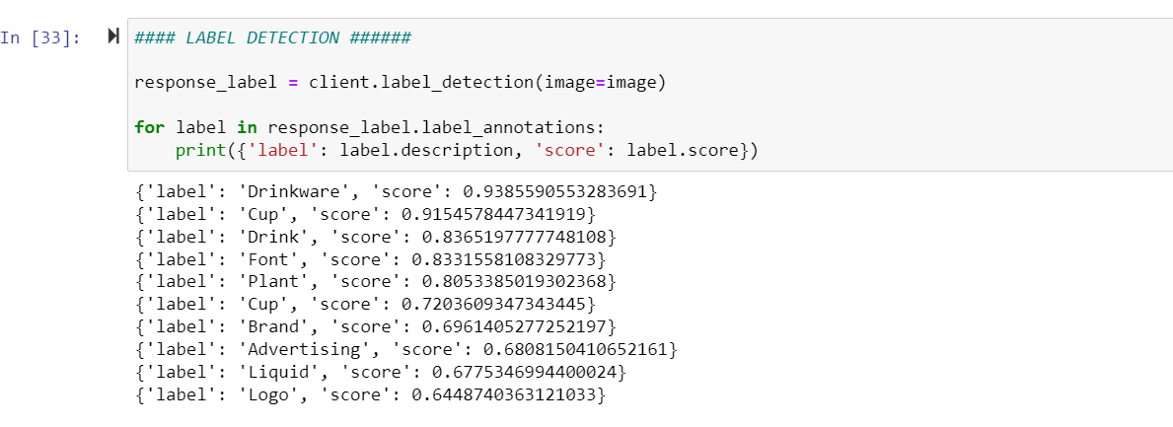

1. LOGO:

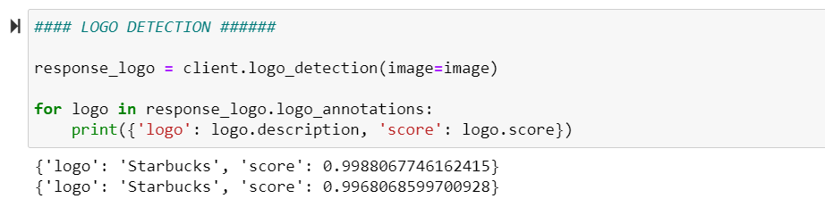

1. BEST GUESS LABEL FOR THE IMAGE:

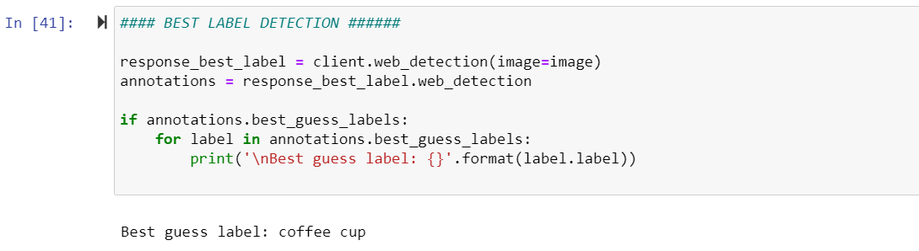

1. TEXT DETECTION:

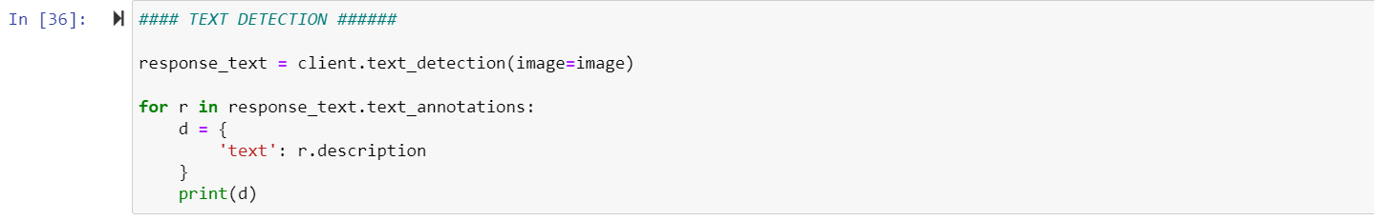

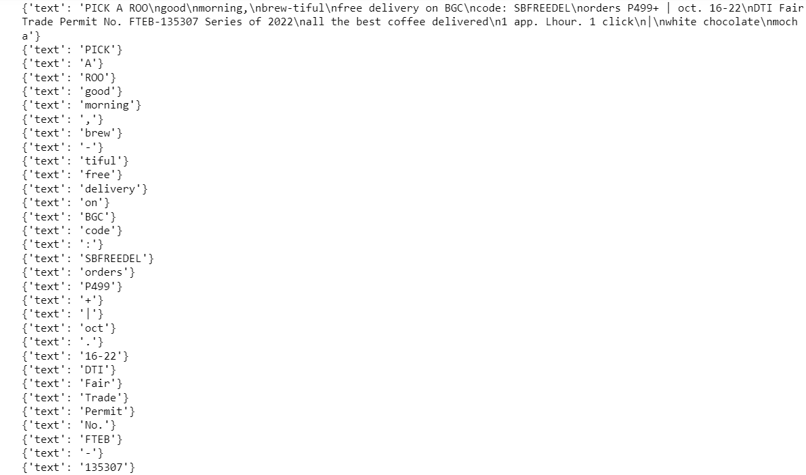

5. The code is not yet complete and needs to be refined to make it capable of taking multiple images as input.